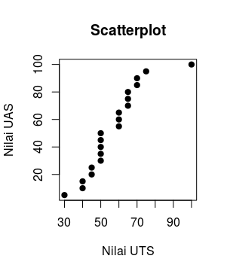

plot(UTS, UAS, main="Scatterplot", xlab="Nilai UTS", ylab="Nilai UAS", pch=19)

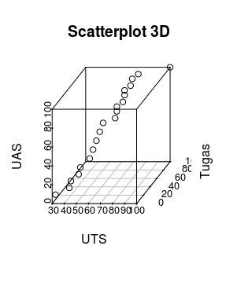

scatterplot3d(data3[,1:3], main="Scatterplot 3D")

**TUGAS 9.2**

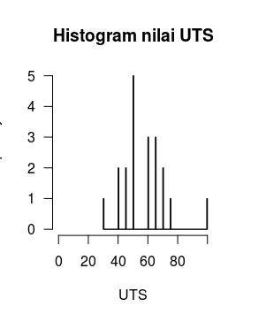hist(UTS, col=heat.colors(max_num), breaks=max_num, xlim=c(0, max_num), right=F, main="Histogram nilai UTS", las=1)

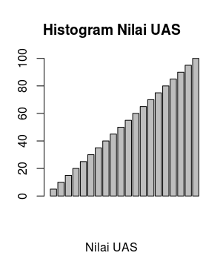

barplot(data2$UAS, main="Histogram Nilai UAS", xlab="Nilai UAS", breaks=5)

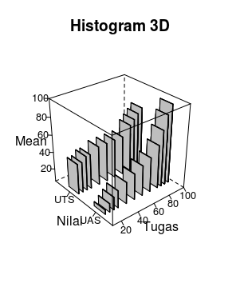

cloud(Mean~Tugas+Nilai, data6, panel.3d.cloud=panel.3dbars, col.facet='grey', xbase=0.4, ybase=0.4, scales=list(arrows=FALSE, col=1), par.settings = list(axis.line = list(col = "transparent")))

**TUGAS 9.3**

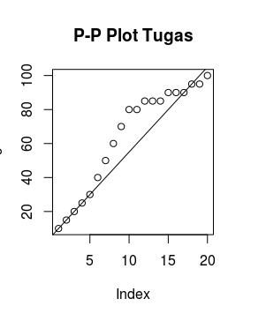

plot(Tugas, main=”P-P Plot Tugas”)

abline(5, 5)

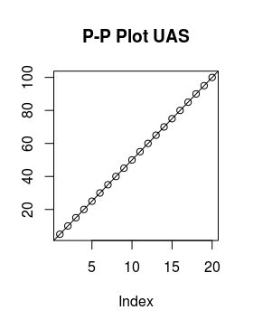

plot(UAS, main=”P-P Plot UAS”)

abline(0,5)

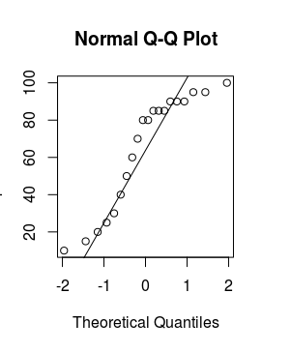

qqnorm(Tugas)

qqline(Tugas, main=”Normal Q-Q Plots Tugas")

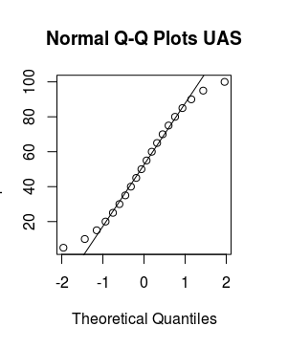

qqnorm(UAS)

qqline(UAS, main=”Normal Q-Q Plots UAS")

**TUGAS 9.4**

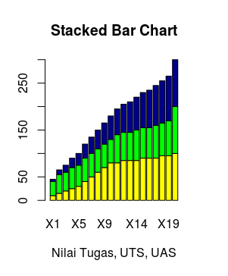

barplot(as.matrix(data7), main="Stacked Bar Chart", col=c("yellow", "green", "darkblue"), xlab="Nilai Tugas, UTS, UAS")

**TUGAS 9.5**

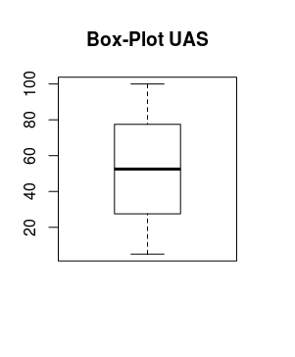

boxplot(UAS, main="Box-Plot UAS")

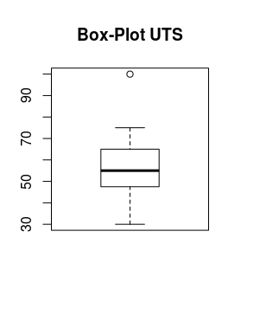

boxplot(UTS, main="Box-Plot UTS")

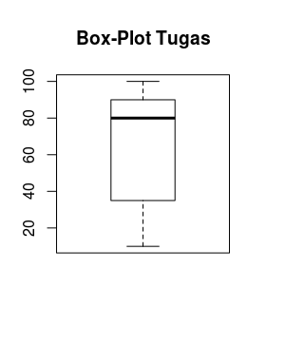boxplot(Tugas, main="Box-Plot Tugas")

**TUGAS 9.6**

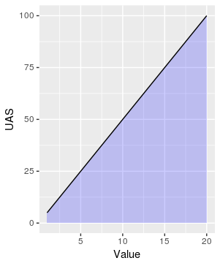

ggplot(data2, aes(x=Value, y=UAS)) + geom_area(fill="blue", alpha=.2) + geom_line()

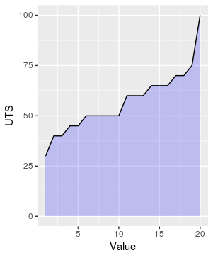

ggplot(data2, aes(x=Value, y=UTS)) + geom_area(fill="blue", alpha=.2) + geom_line()

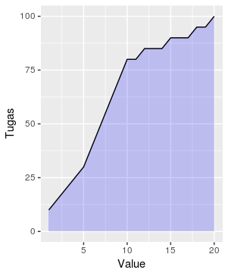

ggplot(data2, aes(x=Value, y=Tugas)) + geom_area(fill="blue", alpha=.2) + geom_line()

**TUGAS 9.7**

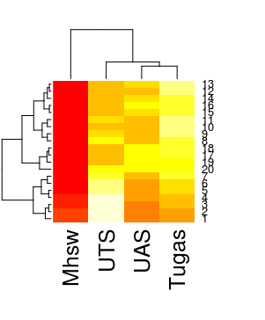

data = as.matrix(data2)

heatmap(data)